

# ST. XAVIER’S COLLEGE (AUTONOMOUS), MUMBAI

# DEPARTMENT OF INFORMATION TECHNOLOGY

# COURSE CODE: S.ITS6.05

**ARTCAB**

### SUBMITTED BY

### RISHABH BANERJEE (UID: 175003) AND SANKET MANDAL (UID: 175039)

### SUPERVISOR: PROFESSOR ROY THOMAS

This Project is submitted to the department of **Information Technology** of **St. Xavier’s College (Autonomous), Mumbai** which is affiliated to the **University of Mumbai.**



**CERTIFICATE**

This is to certify that the project titled **‘ArtCab’**, undertaken at the St. Xavier’s College (Autonomous), Mumbai by **Rishabh Banerjee** and **Sanket Mandal**, in partial fulfilment of the BSc IT degree (Semester VI) examination has not been submitted for any other examination and does not form part of any other course undergone by the candidate. It is further certified that I have completed all the required phases of the project.

**Signature Signature Signature**

**[Internal Guide] [Internal Examiner] [External Examiner]**

**Prof. Roy Thomas**

**[HOD of IT Department]**

**DECLARATION**

We, **Rishabh Banerjee (UID: 175003)** and **Sanket Mandal (UID: 175039)**, hereby declare that this project report entitled: **ArtCab** which is being submitted in fulfilment of the Bachelors of Science in Information Technology Examination conducted by St. Xavier’s College (Autonomous) under Mumbai University is the result of the work carried out by us under the supervision of **Prof. Roy Thomas** of St. Xavier’s College (Autonomous), Mumbai.

This work has not been previously submitted to any other university for any examination. Wherever references have been made to previous work of others, it has been clearly indicated as such and included in the bibliography.

__________________

Rishabh Banerjee

__________________

Sanket Mandal

**ACKNOWLEDGEMENT**

Most importantly, I sincerely thank the Almighty God for giving me strength throughout the preparation of this project proposal. I also wish to extend my sincere and heartfelt gratitude to my loving family for the financial, moral and emotional support, and my classmates and friends who helped in various ways for the successful completion of this project proposal.

Finally, it is a great pleasure for me to also acknowledge the assistance and support of all the people who helped me start and finish this project proposal successfully, especially Prof. Roy Thomas, who has been a great supervisor during this period. I would like to give my special thanks to the Xavier’s fraternity for giving me enough knowledge and skills that made me capable enough to innovatively and successfully research and compile this project proposal.

**ABSTRACT**

The film industry in India is much like a factory which is constantly churning out and producing new content. With the rise of OTT platforms like Netflix, Hotstar, Amazon Prime Video and the like, the Indian audience has adapted very quickly to the changing scenario and as such, it has led to a massive increase in the number of jobs created in this sector. The visual arts industry encompasses everything from movies and TV shows to advertisements and music videos. The nature of these different forms allows everyone - from Directors, Producers and Actors to Spot Boys and Light and Sound Technicians - to carve a niche for themselves in whatever form of the industry that they are best suited to. For example, a Director who is proficient at shooting music videos might not be the best choice to direct a mainstream Bollywood movie, an Actress who does indie movies might not be able to deliver a good performance in an advertisement and so on. On the other side of the spectrum, this aspect of the industry is precisely what allows people to freely switch from one form to another and experiment with their abilities.

Due to this ever-changing nature of the visual arts industry, personal contacts have become a very important factor in determining whether you make it big or not. Your social circle and the people you collaborate with on different projects helps you to gain an upper hand in your future projects.

Keeping all this in mind, we have created a common platform with the objective of levelling the playing field. ArtCab allows you to sign up and list your skillsets and your portfolio, in order to connect with like minded individuals who are looking to collaborate on projects. Some of the primary features of the app include -

* A **Jobs** tab where users can post their requirements for specific projects. Other users can check out the requirements and respond to the post if they fit the criteria.
* A **Studios** tab having a repository of Studios which can be filtered by geographical location. This will allow users to contact Studios for renting cameras, lights, mics, props, and other equipment needed for shooting.
* A **Networks** page which contains a list of profiles, and allows you to filter by profession (DOP, Production Designer, Stylist, Editor, etc).
* An **Ideas** tab. This tab will allow users to put up “stories” which will stay live for 24 hours and then expire. If a user has a concept in mind but doesn’t know how to go about executing it, these stories will let others respond and try to help streamline the execution process.

The development of this application will be based on SDLC with **Android Studio** and **Java** as the programming languages, while **Firebase** servers will serve as the database of the system.

Java is easy to use and provides efficient validation properties, while Firebase Relational Database has advanced features and properties, has good security, is open source and has cross platform operability, as opposed to alternatives like Amazon Web Services and MongoDB. The advantages of using Android Studio and Java programming language in developing this system include:

* It is a stable open source language developed and maintained by a large group of Java developers which helps in creating a support community and an abundant extension library.
* It can be run on many platforms thus makes it easy for users to find hosting services.
* It has built-in database connection modules which makes it easy to connect to the database.

**TABLE OF CONTENTS**

|  |  |  |
| --- | --- | --- |
| Sr. No | Particulars | Page No. |
| 1) | Introduction | 8 |
| 2) | Methodology | 11 |
| 3) | Overall Description | 12 |
| 4) | Analysis and Design | 16 |
| 5) | ER Diagram | 23 |
| 6) | Planning | 27 |
| 7) | Implementation and Testing | 29 |
| 8) | Diagram and Visualization |  |
| 9) | Databases |  |
| 10) | System Coding |  |
| 11) | Conclusion |  |
| 12) | Future Enhancement |  |
| 13) | Goals and Achievement |  |
| 14) | References |  |

**Introduction**

Social media has become a very integral part of life in the 21st century. As stated by Sean Parker in the movie The Social Network, “You don’t just go to a party anymore, you go to a party with your digital camera and your friends relive the experience on Facebook.” This was over 10 years ago, and Sean Parker’s words still stand true. Social media has changed the way we interact with people, the way we consume content, and has percolated through to even the most basic experiences of our daily lives. You don’t just go out for dinner anymore. You pick a photogenic dish, look for good angles, select the appropriate hashtags, geotag the restaurant you’re at, and tweet what your dinner is. Other than our personal lives, social media also has a strong role to play in our professional lives. LinkedIn has revolutionized the experience of connecting with your coworkers. You no longer have to worry about what your boss might think when you share personal pictures on Facebook, simply because you add your boss as a connection on LinkedIn and not on Facebook anymore.

In Peter Thiel’s book “Zero to One: Notes on Startups, or How to Build the Future”, he says that it is easier to copy a model than to make something new. Doing what we already know how to do takes the world from 1 to n, which basically means improving something which is already familiar. But every time we create something new, we go from 0 to 1. The act of creation is singular, as is the moment of creation, and the result is something fresh and strange.

However, we believe that a lot of people get stuck on the “0 to 1” trap. When you get caught up in the allure of creating something new, which is more difficult than people expect, your competitors might be going from “1 to n” and eating your lunch. Strictly speaking, not all truly innovative design is “0 to 1”. Facebook was built on ideas that were improvements over Friendster and MySpace. But it is important to note that that Facebook’s improvements were not incremental improvements. Rather, Facebook started doing things differently from a new ground.

Similarly, keeping the “1 to n” principle in mind, we have come up with ArtCab, a platform which focuses exclusively on the networking aspects of the visual arts industry.

**Problem Statement**

The film industry in India is a game of contacts - everyone on set, from junior artists and background dancers to spot boys and the choreographer, depends on contacts to get their next job. Bollywood is a highly cosmetic version of the gig economy. As such, people depend on their personal contacts to go from one project to the next. Understandably, this makes it difficult for newcomers to enter the industry. This is precisely the reason why the recent years have seen a rise in the launch of so called “star kids” in Bollywood and accusations of nepotism. However, this problem is not limited to actors or actresses and actually permeates much deeper to all levels of the hierarchy.

ArtCab aims to bridge this gap by providing a common platform for artists to showcase their ideas and collaborate with other like-minded individuals. It will allow users to list their skillsets and portfolio, and build up a network of sorts. This will help out of work technicians, dancers, actors etc. to reach out to a larger number of people and hopefully transform it into an opportunity to work with them.

**Objectives**

**General Objectives**

* To take the entire experience of the social aspects of the visual arts industry, and putting it online
* To help artists increase their visibility
* To eradicate the borders of opportunity for talented artists in the film industry
* To upgrade the amateur section of the crowd to professionals without having to rely on contacts in the industry
* To fuel creativity and collaboration amongst the young aspirers of the industry who are sick of the nepotism present in the system

**Specific Objectives**

* Increasing the opportunity for the people interested by enabling every user to browse through collective visions
* Facilitating communication through the platform without having to release sensitive personal information
* Enabling like-minded people to connect and work on projects they would love to work on
* Users don’t require high profile contacts anymore to rise in their careers in filmmaking
* To provide most of the components required to work on a project and also the access to innumerable people looking to collaborate and share
* Enabling users to browse jobs and opportunities in a sector where finding one is tough without a few well-connected people

**Methodology**

Most modern applications are developed in the span of 6–10 weeks. Let us go through the method of developing a mobile app.

**Week 1: Requirement Analysis**

Study the app in detail and list down the features that your app requires. Look into the requirements about what could be the best tools for developing an app. Prepare a list of required items and install the necessary software on your system.

**Week 2: UX/UI designing**

Prepare use cases and flowcharts. Break each element into deliverables and lay down a strategy to go ahead with. Work on the design part (UI/UX) and prepare a design that delivers the best user experience. Test it on different devices. Ensure smooth navigation on the mobile app.

**Week 3 and 4: Coding**

While working on designing, start implementing the back-end processes. Deploy each functionality one by one and keep testing it. The coding part eats your time here but if you have your plan defined, coding will not be a burden.

**Week 5: Testing and modifications**

Test the functionalities and make necessary changes. Ask dummy users to use the app and make necessary changes according to their inputs.

**Week 6: Launching**

Once you are through with all the above steps, you can now launch your application. Complement the launch with a strong marketing plan.

**Overall Description**

**Weaknesses of the current system**

* Reliability on contacts in the industry to get projects
* Less visibility for new artists
* Rampant nepotism in the higher rungs of the industry, especially in the so called “star families”

**Merits of the proposed system**

* Increasing the visibility of independent artists
* Enabling artists to connect with each other regardless of their social circles
* Enabling studio owners to increase their visibility and rent out spaces and equipment to a larger audience
* Helping like minded individuals come together to collaborate and create independent and non-commercial art

**Feasibility Study**

Feasibility study is an evaluation and analysis of the potential of the proposed project which is based on extensive investigation and research to support the process of decision making. It assesses the operational, technical and economic merits of the proposed project. The feasibility study is intended to be a preliminary review of the facts to see if it is worthy of proceeding to the analysis phase. From the systems analyst perspective, the feasibility analysis is the primary tool for recommending whether to proceed to the next phase or to discontinue the project.

**i) Technical Feasibility**

This assessment is focused on gaining an understanding of the present technical resources of the organization and their applicability to the expected needs of the proposed system. It is an evaluation of the hardware and software and how it meets the needs of the proposed system. The systems project is considered technically feasible if the internal technical capability is sufficient to support the project requirements. The essential questions that help in testing the technical feasibility of a system include the following:

* Is the project feasible within the limits of current technology?
* Does the technology exist at all?
* Is it available within given resource constraints?
* Is it a practical proposition?
* Is there enough manpower - programmers, testers & debuggers?
* Does the required software and hardware exist?
* Are the current technical resources sufficient for the new system?
* Can they be upgraded to provide the level of technology necessary for the new system?
* Do we possess the necessary technical expertise, and is the schedule reasonable?
* Can the technology be easily applied to current problems?
* Does the technology have the capacity to handle the solution?
* Do we currently possess the necessary technology?

It is possible to develop this app using Android Studio and Java as the front-end tools and Firebase as the back-end tool. It will serve a large user base.

**ii) Operational Feasibility**

Operational feasibility is the measure of how well the project will support the customer and the service provider during the operational phase. It is dependent on human resources available for the project and involves projecting whether the system will be used if it is developed and implemented. The essential questions that help in testing the technical feasibility of a system include the following:

* Is the project feasible to operate or not?
* Does current mode of operation provide adequate throughput and response time?
* Could there be a reduction in cost and/or an increase in benefits?
* Does current mode of operation offer effective controls to protect against fraud and to guarantee accuracy and security of data and information?
* Does current mode of operation make maximum use of available resources, including people, time, and flow of forms?
* Are the current work practices and procedures adequate to support the new system?
* If the system is developed, will it be used?
* Does it agree with the government regulations?
* Will the proposed system really benefit the organization?
* Will the system affect the customers in considerable way?
* How do the end-users feel about their role in the new system?
* How will the working environment of the end-user change?

The product has high applicability among a variety of users. Being lightweight, accurate, and easy to use, a wide user base is expected. Furthermore, there is no similar service on the market, which will help in gaining a lot of users. Hence, the project is operationally feasible.

**iii) Economic Feasibility**

This assessment aims to determine the positive economic benefits to the organization that the proposed system will provide. It typically involves a cost/benefits analysis and it’s the most frequently used method for evaluating the effectiveness of a new proposed system. Possible questions raised in economic analysis are:

* Is the system cost effective?
* Do benefits outweigh costs?
* The cost of doing full system study
* The cost of business employee time
* Estimated cost of hardware
* Estimated cost of software/software development
* Is the project possible, given the resource constraints?
* What are the savings that will result from the system?
* Cost of employees' time for study
* Cost of packaged software/software development
* Selection among alternative financing arrangements (rent/lease/purchase)

Considering that this is a personal project, ROI and profit in terms of money is not expected. However, we did take into consideration whether developing the product itself was within budget. The cost of a suitable workstation, libraries, test devices (or emulators), and other

components was found to be within budget. The project is indeed economically

feasible.

For the end user, there are no charges other than what is incurred in data/Internet connection charges in order to use the app.

**iv) Schedule Feasibility**

It is the measure of how reasonable the project time table is or whether the deadline is reasonable or not. It mainly addresses:

* Can the project really be completed in the given period of time?

Since there is a well-defined schedule in place, we are confident that the development process will be completed on time.

**v) Legal Feasibility**

No data is saved by the application without the explicit consent of the user. Therefore, data privacy and other similar legal issues do not apply.

The project is open source and the code can be used and modified.

**Analysis and Design**

Development of computerized systems requires analysis of the process to be digitized in order to enable a correct system, a system that functions as required and to assist the potential users of the system understand the general functionality of the system. The analysis specifies the system's objectives and constraints to which designers have to comply. The purpose of doing analysis is to transform the system’s major inputs into structured specification.

**Context Diagram**

This is a brief structure which depicts the environment in which a software system exists and helps in communicating about what lies outside the system boundary.

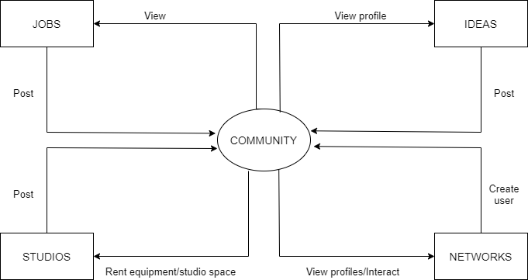

**Data Flow Diagram**

It is a two-dimensional diagram that explains how data is processed and transferred in a system. The graphical depiction identifies each source of data and how it interacts with other data sources to reach a common output.

**Networks Module**

Functionalities provided:

* Filter profiles by specialization
* View complete profiles (quotes, portfolio, work links etc.)
* Connect with people over WhatsApp, Instagram or email

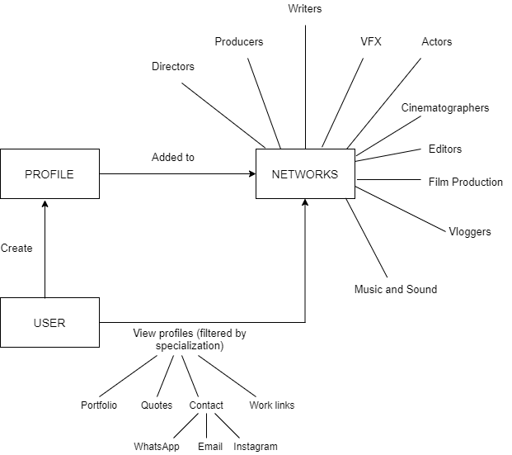

**Jobs Module**

Functionalities provided:

* Post jobs with detailed information about requirements such as location, job description, remuneration etc.
* View profiles of people who have posted jobs and connect with them over WhatsApp, Instagram or email

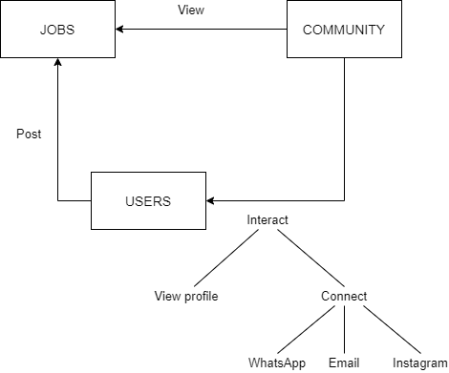

**Ideas Module**

Functionalities provided:

* Post ideas which will be visible for 24 hours
* View profiles of people who have posted ideas and connect with them
* Filter ideas by genre

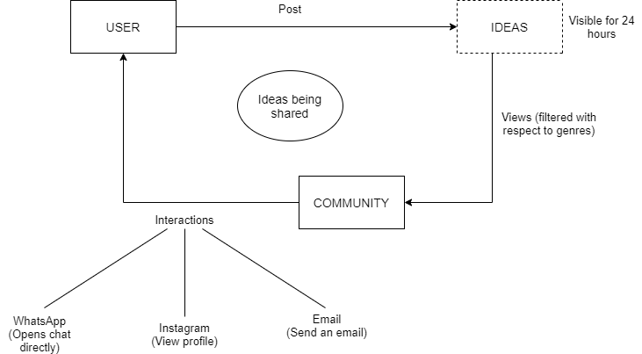

**Studios Module**

Functionalities provided:

* Post studio information
* Post information about light, sound and camera equipment available for renting
* Lets you post multiple photos, location, rent etc.
* Users can view the location on Google Maps
* Users can connect with studio owners over WhatsApp, Instagram or email

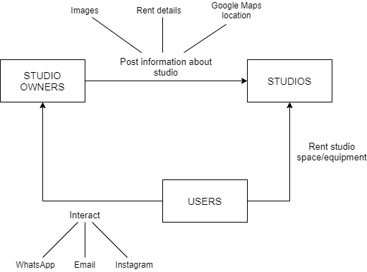

**User requirements:**

The system will be designed to be user friendly. The user friendly and interactive interfaces design helps to achieve this by enabling users to easily browse through the various tabs, connect with people in just a few clicks, and also respond to queries with minimal delay and confusion. The system will be simple to use.

**Functional requirements:**

Functional requirements define the capabilities and functions that a system must be able to perform successfully. The functional requirements of this online ordering system include:

* The system shall enable the user to create an account, login to the system and specify his/her specializations
* The user can fully customize his/her profile and can add a profile picture, favourite movie quotes, portfolio, links to previous work etc.
* The system shall display all users in the Networks section and will allow filtering by specialization
* The system shall display jobs in the Jobs tab
* The system shall display studio information in the Studios section
* The system shall display ideas (similar to “stories”, which will be visible for 24 hours) and will allow filtering by genre
* The system will allow users to connect with each other using WhatsApp, Instagram or email

**Non-functional requirements:**

A non-functional requirement is a requirement that specifies criteria that can be used to judge the operation of a system, rather than specific behaviors. Some of the non-functional requirements include:

* There should be sufficient network bandwidth
* Backup - provision for data backup
* Maintainability - easy to maintain
* Performance/response time - fast response
* Usability by target user community - easy to use
* Expandability - needs to be future proof or upgradable
* Safety - should be safe to use

**System requirements:**

These consist of the software components which a target device is expected to have in order to install and use the application efficiently.

* Any Android phone with API level 21 or above
* Android version Lollipop or above

**Hardware requirements:**

These consist of the hardware and software components of the computer system which was used to develop the project.

* Microsoft Windows 7/8/10 (64 bit)
* 4 GB RAM minimum, 8 GB recommended
* 2 GB of available disk space minimum, 4 GB recommended (500 MB for IDE + 1.5 GB for Android SDK and emulator system image)
* 1280 x 800 minimum screen resolution

**ER Diagram**

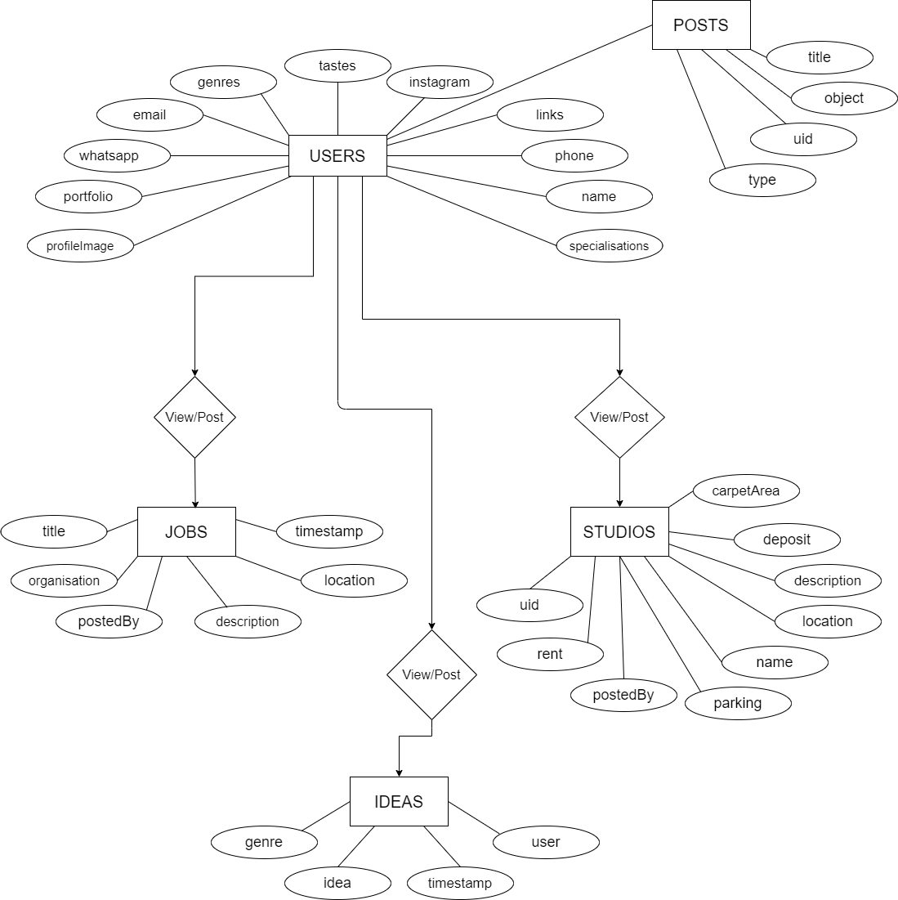

The diagram shown is an entity relationship diagram, depicting the working of ArtCab. ER diagram reflects the relationships that various entities involved in the system share among themselves, along with the entities.

Following are the description of entities involved in ArtCab:

**Users**

*profileImage* - This is the image which users can set for themselves on their profile. It serves to identify each unique user.

*portfolio -* Users can upload their portfolio (if applicable) for others to view

*whatsapp -* Contains the user’s WhatsApp contact number

*email -* Contains the user’s email address

*genres -* Users can set their preference of film genres. It is an ArrayList containing values of different genres like comedy, horror, thrillers etc.

*tastes* - Users can set their preference of taste in movies. It is an ArrayList containing values like Bollywood, Hollywood, indie etc.

*instagram* - Contains the user’s Instagram handle

*links* - Contains links to user’s previous works, such as YouTube videos

*phone* - Contains the user’s phone number

*name* - Contains the user’s name

*specializations­* - Users can set their specializations. It is an ArrayList containing values such as Director, Producer, VFX, Vlogger, Cinematographer etc.

**Posts**

*title* - The title of the post (such as job title)

*object* - It is a database reference to posts which redirects to the post made.

*uid -* A unique ID is assigned to each post

*type -* The type of the post, such as whether it is a job post, studio post etc.

**Jobs**

*title -* The job title (for example, “Videographer needed with experience in shooting with RED Epic camera”)

*organization* - The organization which has posted the job

*postedBy -* User information of the person who has posted the job

*description -* Details about the job, such as remuneration, project duration, work hours etc.

*location* - Job location (for example, Mehboob Studios, Bandra West)

*timestamp -* Time of creation of the job post

**Ideas**

*genre -* ArrayList containing values of different genres like comedy, horror, thrillers etc.

*idea -* The description of the idea

*timestamp -* Time of creation of the idea

*user -* User information of the person who has posted the idea

**Studios**

*uid -* A unique ID is assigned to each studio

*rent -* Rent details of the studio

*postedBy -* User information of the person who has posted about the studio

*parking -* Binary attribute containing the values yes/no regarding whether the studio has parking space available

*name -* Contains the name of the user who has created the post, i.e. the studio owner/proprietor

*location* - Contains the location of the studio and its Google Maps link

*description* - Further details about the studio such as opening and closing time, landmark etc.

*deposit* - Amount to be paid as deposit upfront

*carpetArea -* Area of the studio in sq. foot

**Planning**

**Time scheduling (Gantt Chart)**

|  |
| --- |
| ArtCab |

|  |  |  |  |  |  |  |  |
| --- | --- | --- | --- | --- | --- | --- | --- |
|  | October 2019 | November 2019 | December  2019 | January 2020 | February 2020 | March 2020 | April 2020 |
| Research & data collection |  |  |  |  |  |  |  |
| Proposal waiting |  |  |  |  |  |  |  |
| Proposal approval & project starting time |  |  |  |  |  |  |  |
| Coding, design and testing |  |  |  |  |  |  |  |
| Deployment and documentation |  |  |  |  |  |  |  |
| Project presentation |  |  |  |  |  |  |  |

**Budget**

|  |  |
| --- | --- |
| **ITEM DESCRIPTION** | **AMOUNT** |
| Firebase Console | Free |
| Google Console | Free |
| Android Studio | Free |
| Laptop | 45,000 |
| Stationery and printing | 1000 |
| **TOTAL:** | **46,000** |

**Process model**

For our project we plan to use Waterfall model as a process model. The Waterfall Model is a sequential design process, often used in software development processes, in which progress is seen as flowing steadily downwards (like a waterfall) through the phases of Conception, Initiation, Analysis, Design, Construction, Testing and Maintenance.

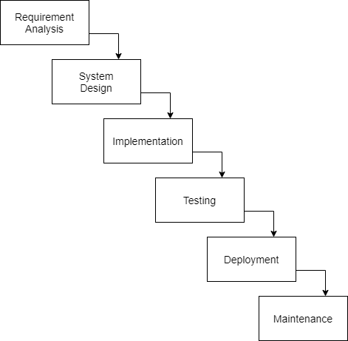

**Implementation and Testing**

**Logo Splash Screen**

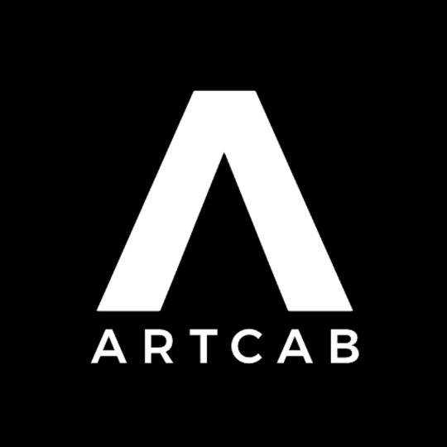

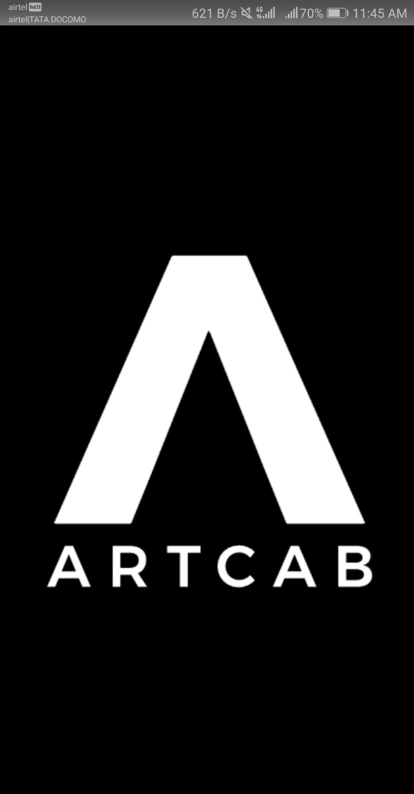

On opening the app, the Networks page is shown by default. It shows you the list of people you can connect with.